Types of Wallet Systems
# Source: AI Source: Provided by: [Data Path: Persons Table -> ID Column: 1, Name_En Column: Motasem Essam] -> From: [ChatGPT] on [1/21/2026]
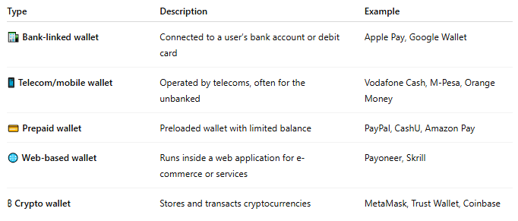
Type | Description | Example
🏦 Bank-linked wallet | Connected to a user’s bank account or debit card | Apple Pay, Google Wallet
📱 Telecom/mobile wallet | Operated by telecoms, often for the unbanked | Vodafone Cash, M-Pesa, Orange Money
💳 Prepaid wallet | Preloaded wallet with limited balance | PayPal, CashU, Amazon Pay
🌐 Web-based wallet | Runs inside a web application for e-commerce or services | Payoneer, Skrill
₿ Crypto wallet | Stores and transacts cryptocurrencies | MetaMask, Trust Wallet, Coinbase

